Available lunch places near venue

Most eating places can be found in or close to shopping centre “Molas” – Barsausko g. 66 A., Kaunas.
Here is map how to reach “Molas” from the venue.
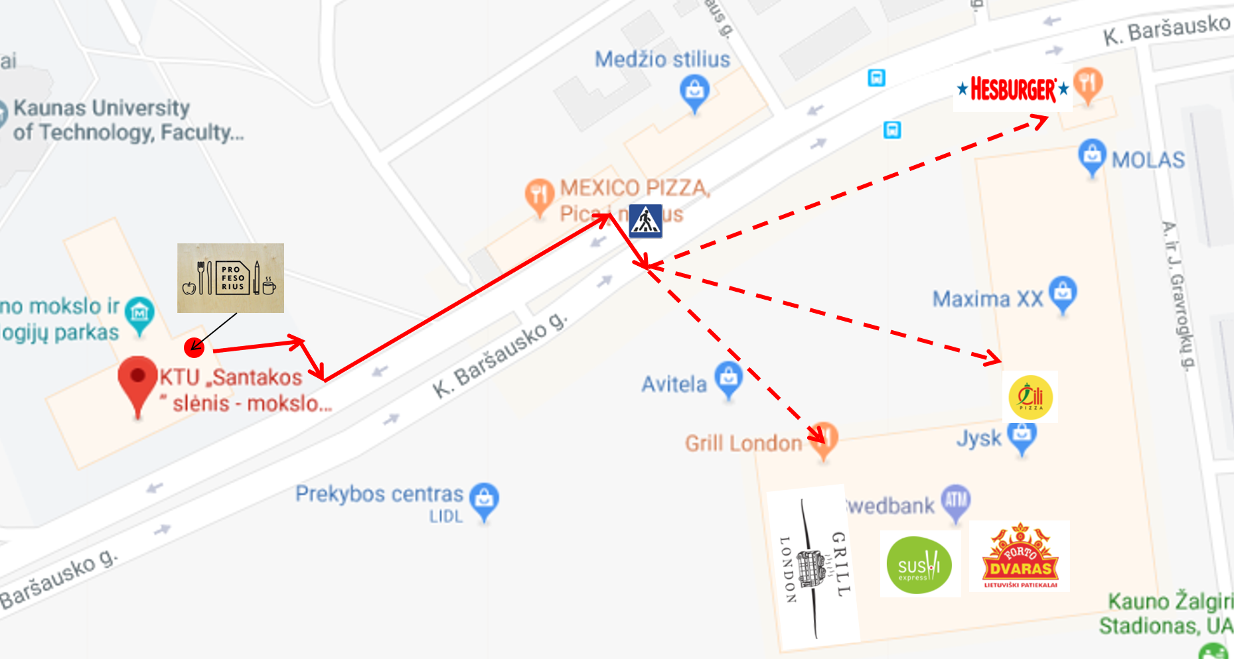

Restaurants in Molas:
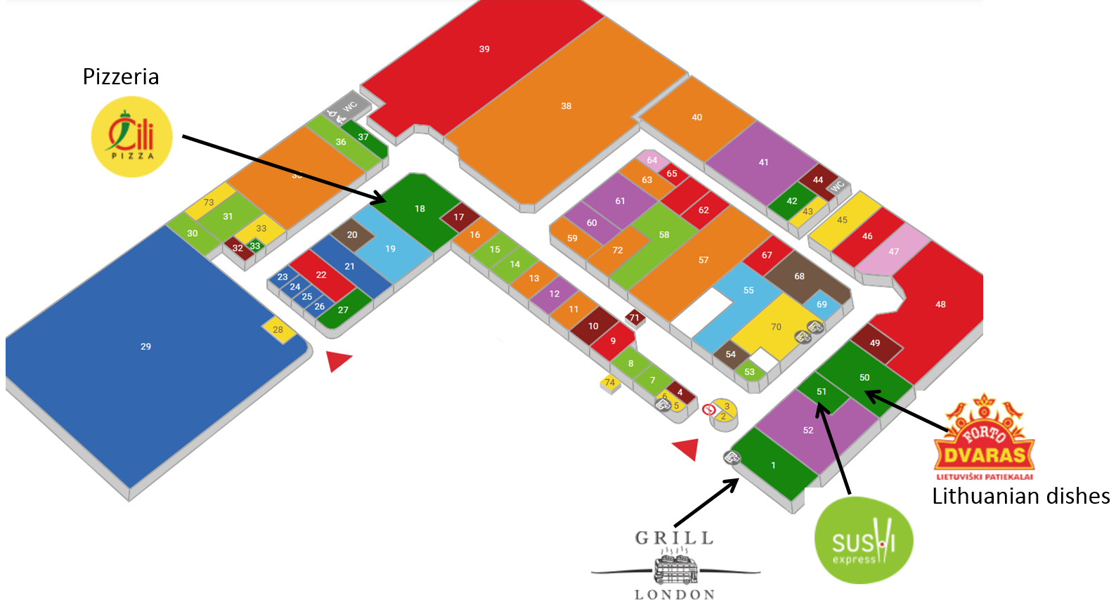

This document is available at: 